**The Bible school construction progress.**

**Preamble:**

The Lord Jesus Laid a burden in my heart to build a Bible school to teach righteousness. He miraculously provided 5 ½ acres land for the Bible school. I was given a donation of Bibles, Christian Teaching Books from Rhema Chapel in USA by the Kenneth Hagin ministries. I also received many more Christian Books from friends in Germany, Netherlands, China, USA and South Africa. Several brothers and sisters have been donating for the Bible school construction. We have built most of the building on a flat solid rock.

If we are to move faster, we need more prayers, support and donations.

The following photos show the way we have constructed the buildings by the grace of our Lord Jesus Christ.

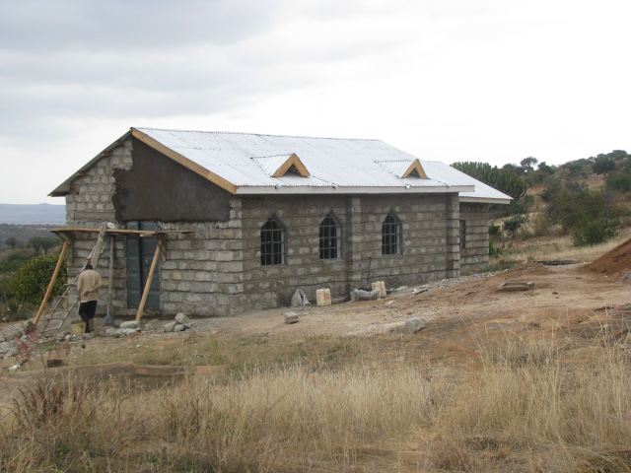

**2013 start of chapel construction.**

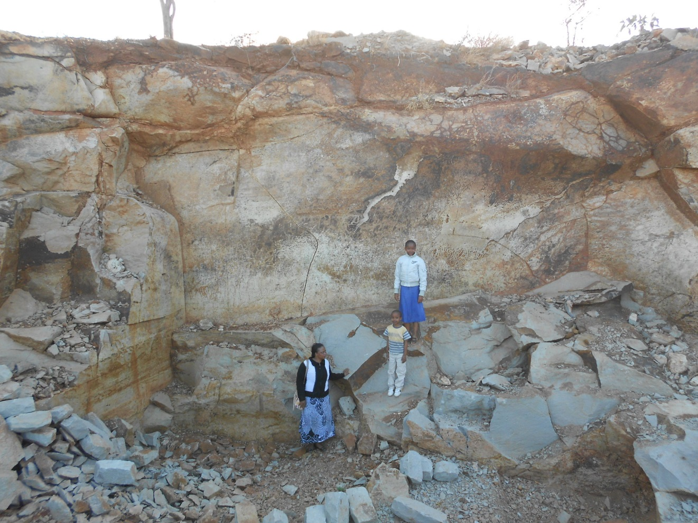

**Purchase of a quarry for blocks for the construction**

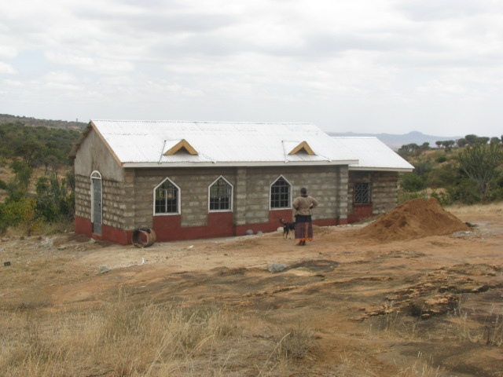

**Plastering the chapel.**

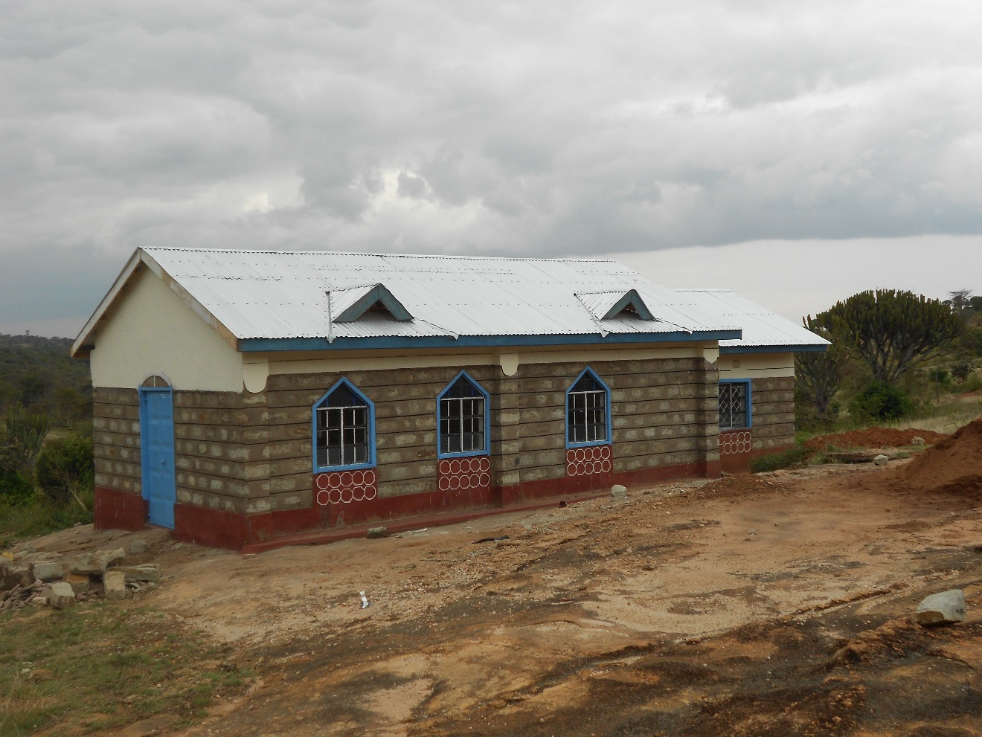

**The progress of the chapel construction**

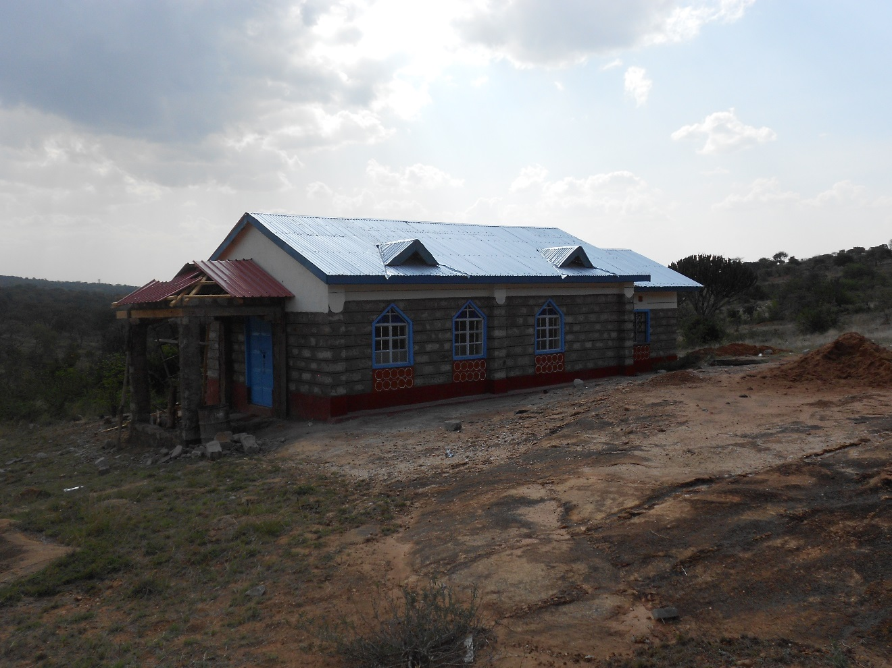

**Construction of the chapel corridor.**

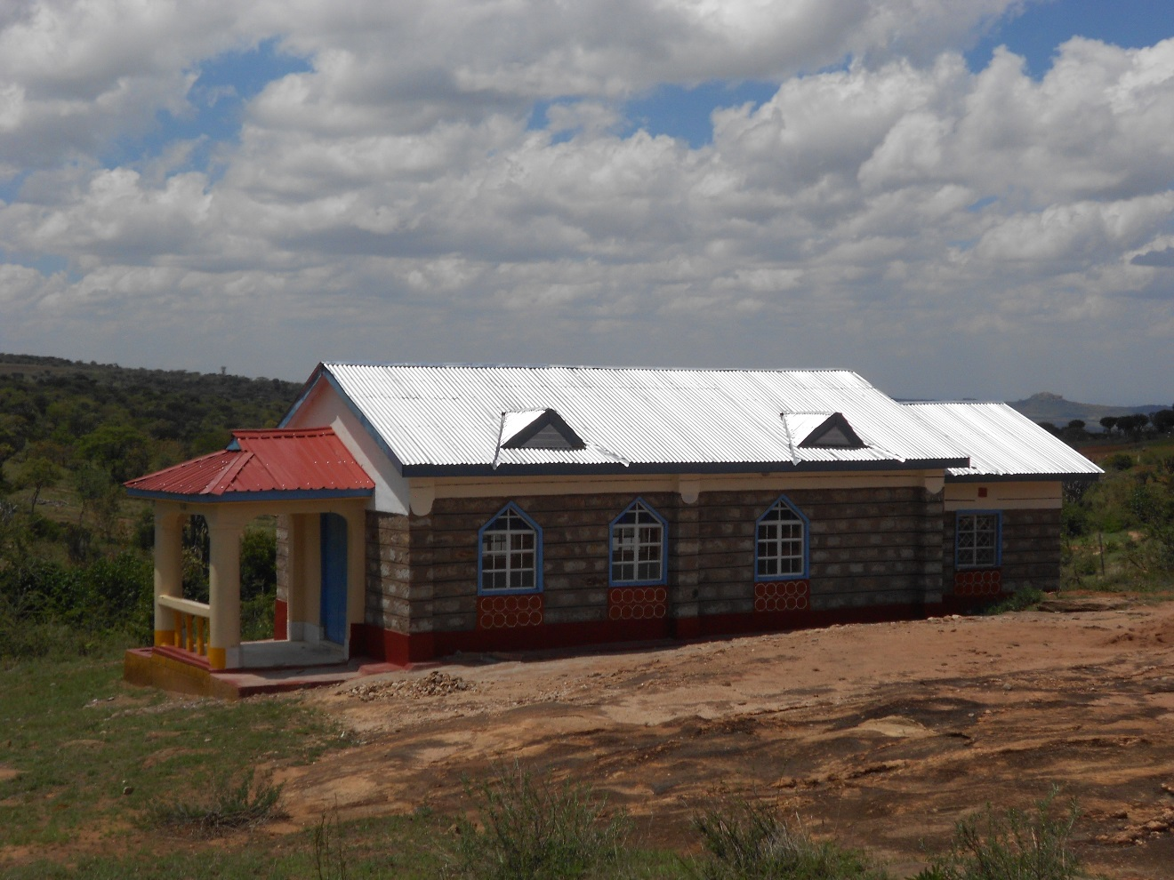

**The corridor of the chapel finished.**

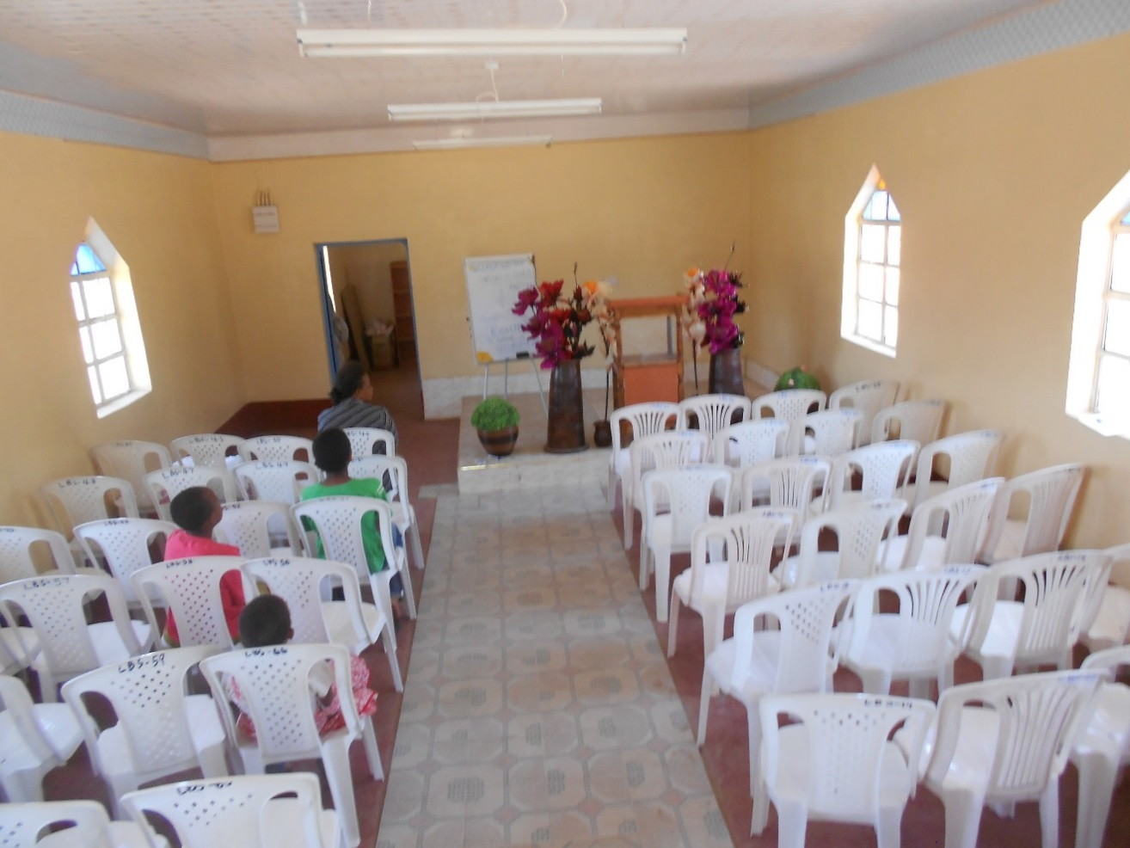

**Inside the chapel, with chairs and complete electricity wiring**

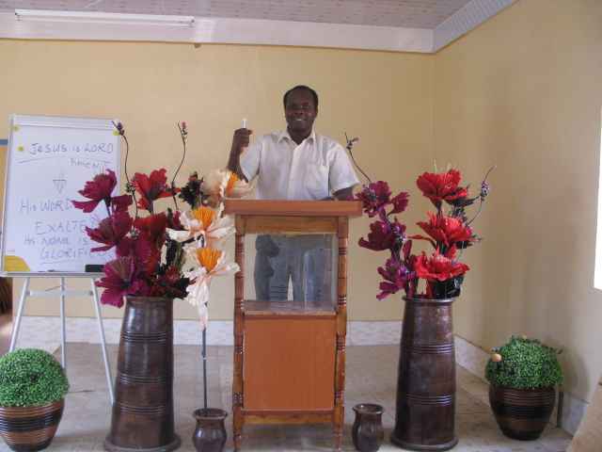

**Dr. Josphert, Testing the chapel pulpit.**

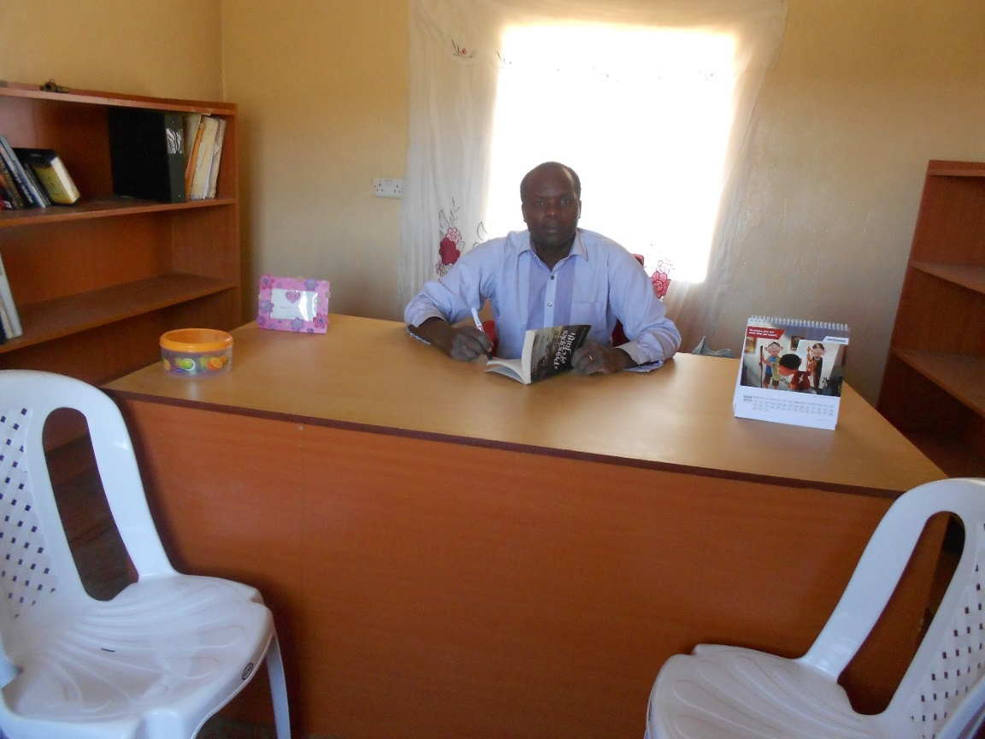

**Inside the Pastors, preparation room.**

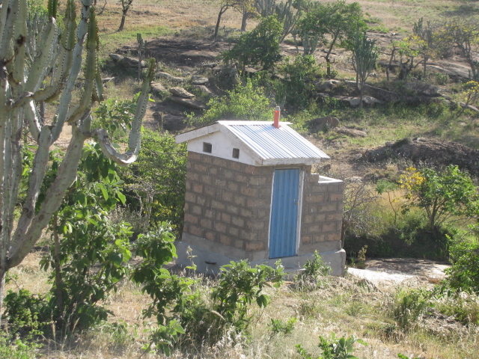

**The construction of the latrines for both ladies and gents.**

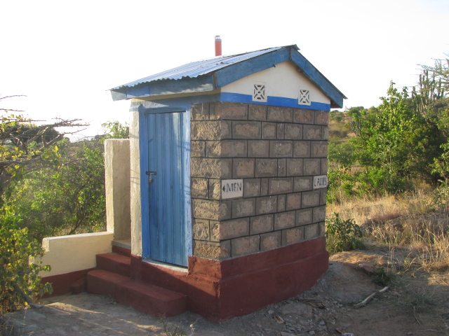

**Complete latrines with labels and a urinal; glory to God Almighty.**

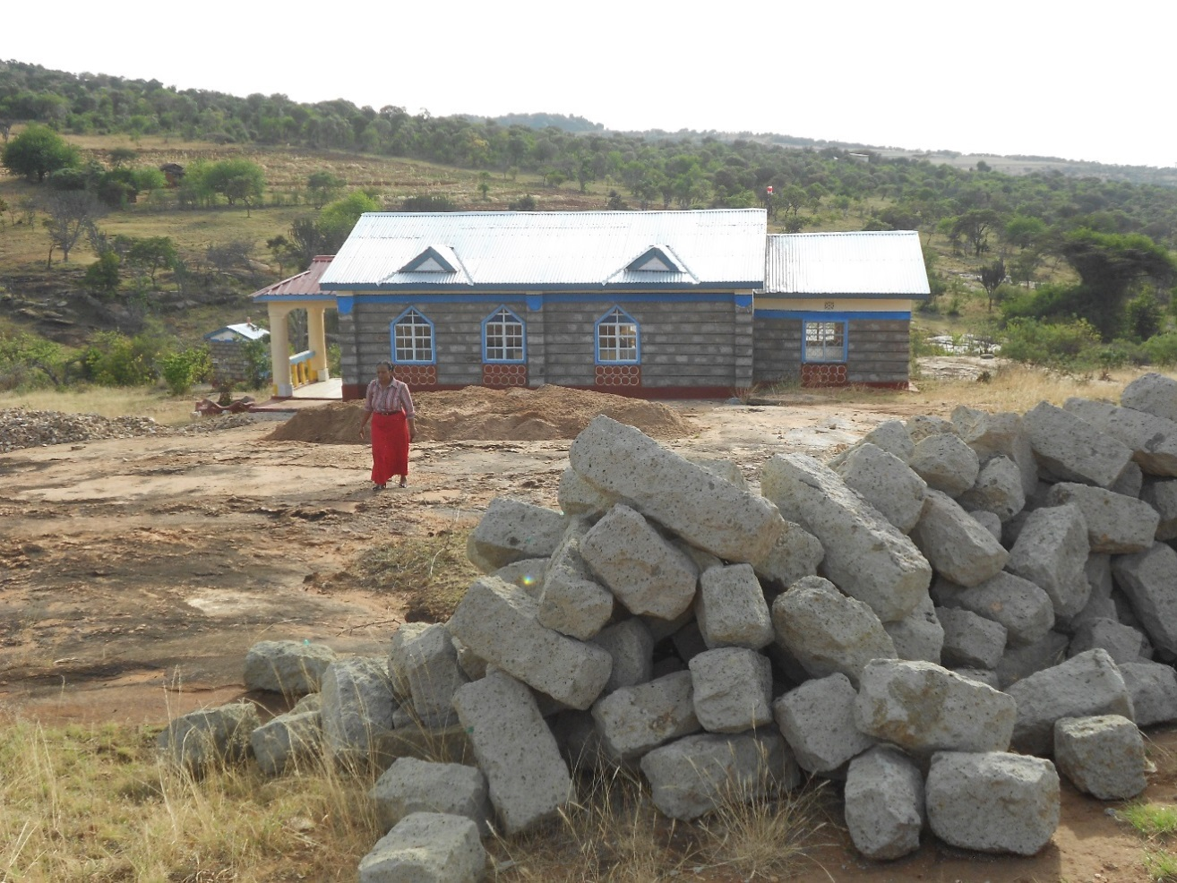

**The collection of more materials for further construction.**

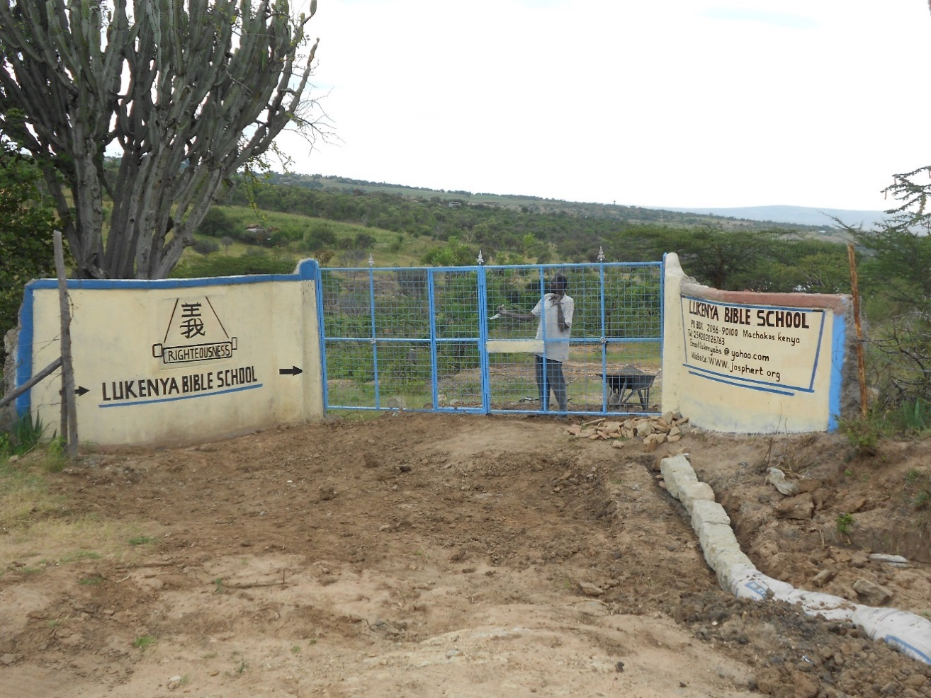

**The construction of the gate, bearing the banner for the vision of righteousness.**

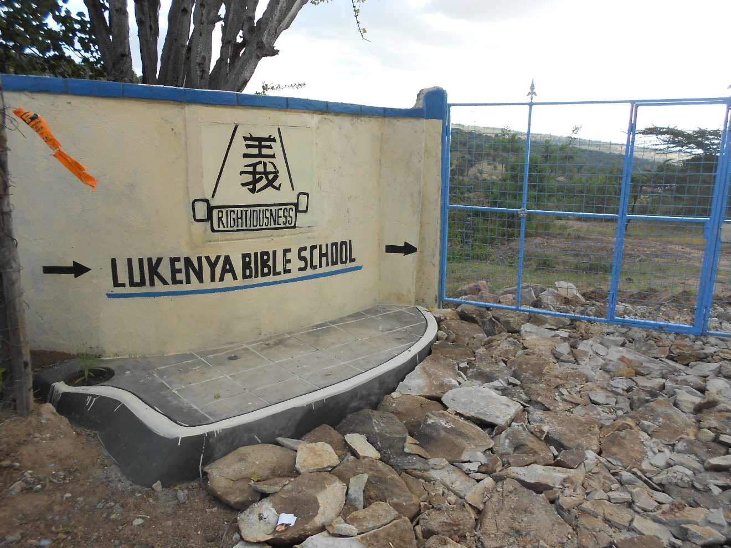

**The gate at a close range.**

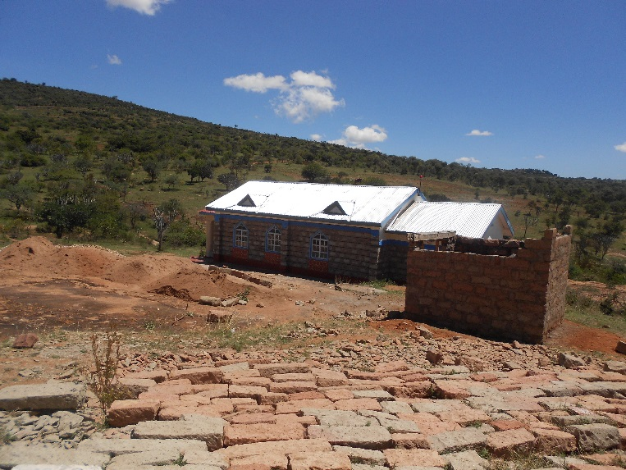

**The construction of a store for keeping building equipment**

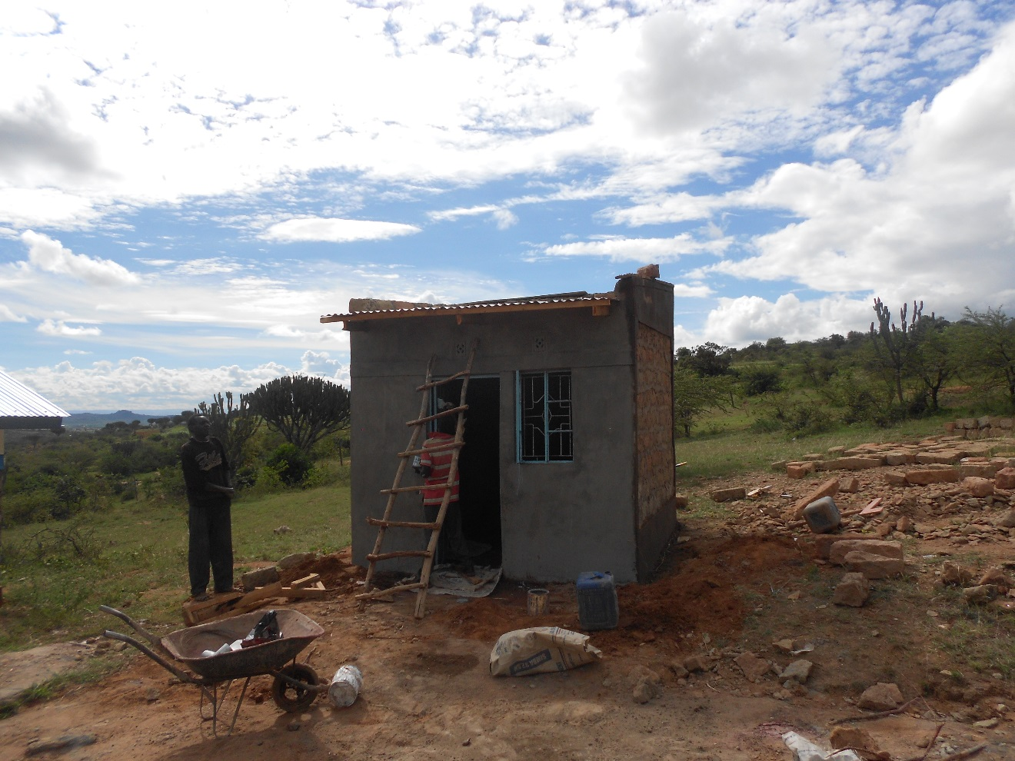

**The roofing of the store.**

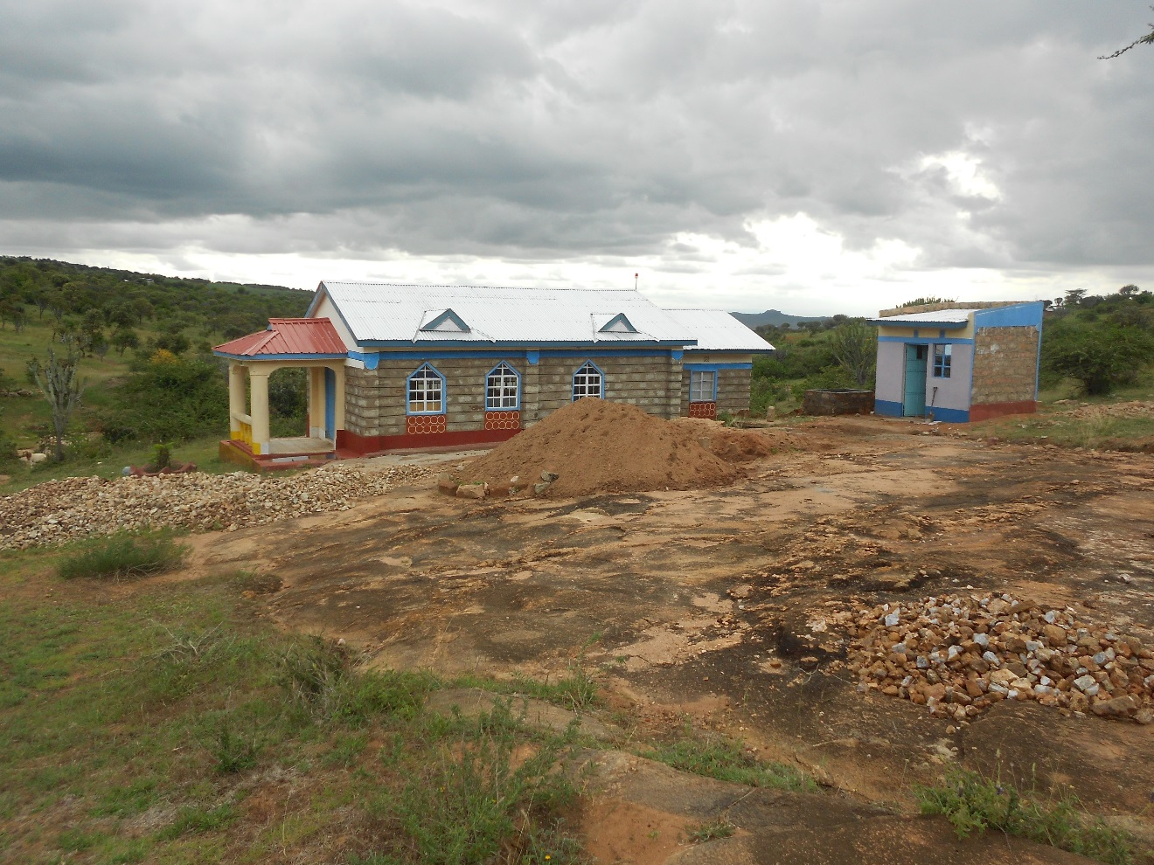

**The completion of the store.**

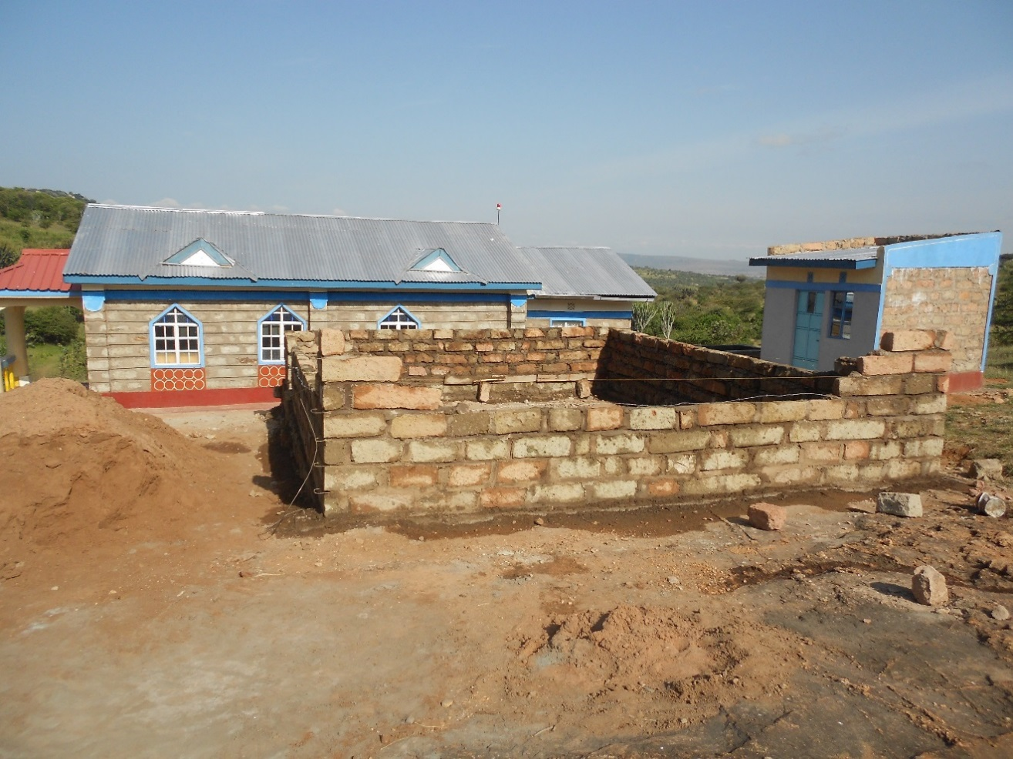

**The start of the construction of the first classroom.**

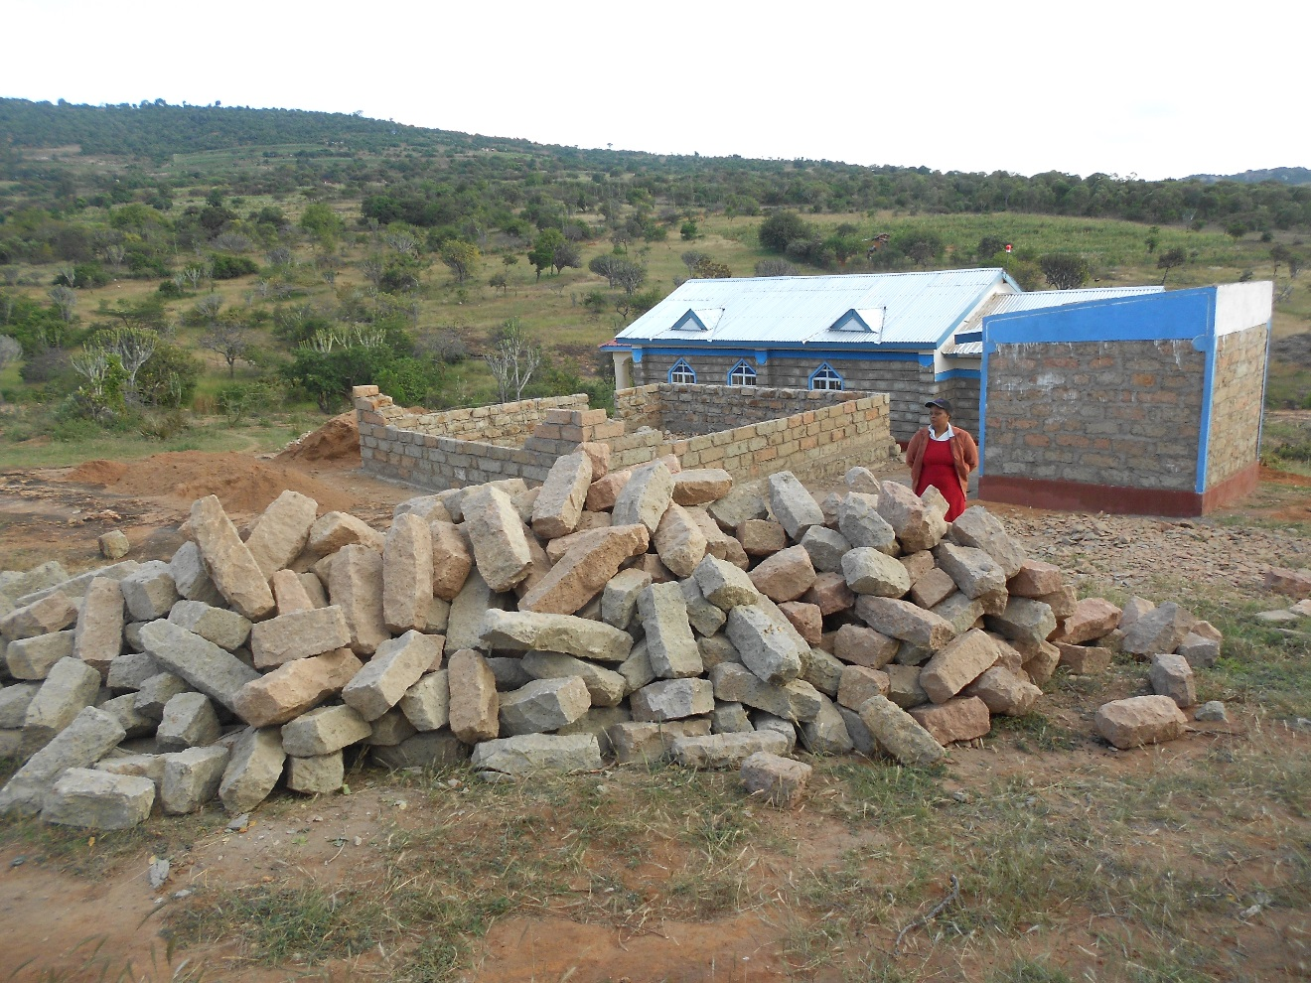

**More building material availed as the first class was in construction.**

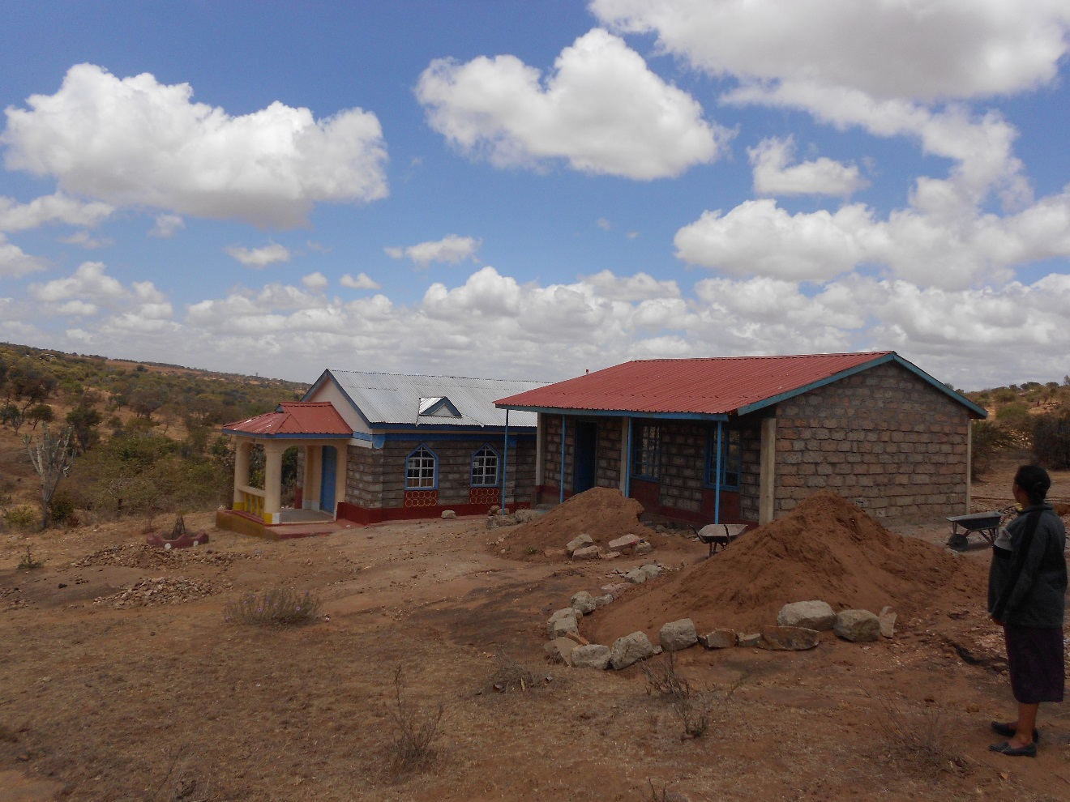

**The first class is almost complete.**

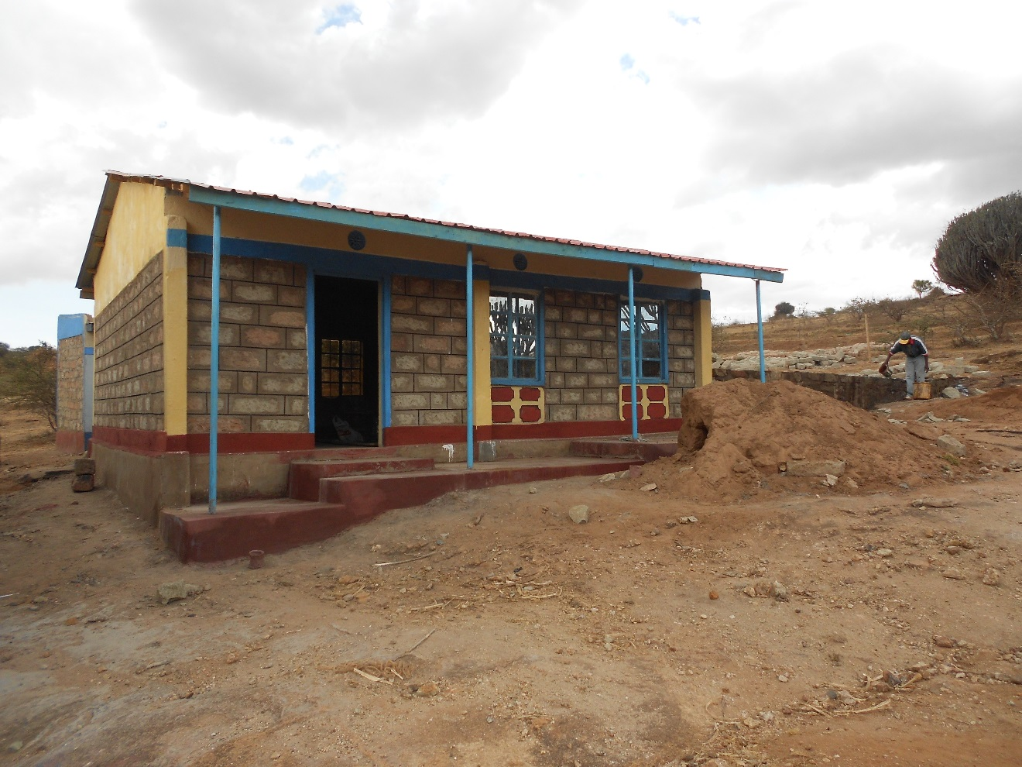

**The first class is completed and the second class is started as at 17th October 2015**

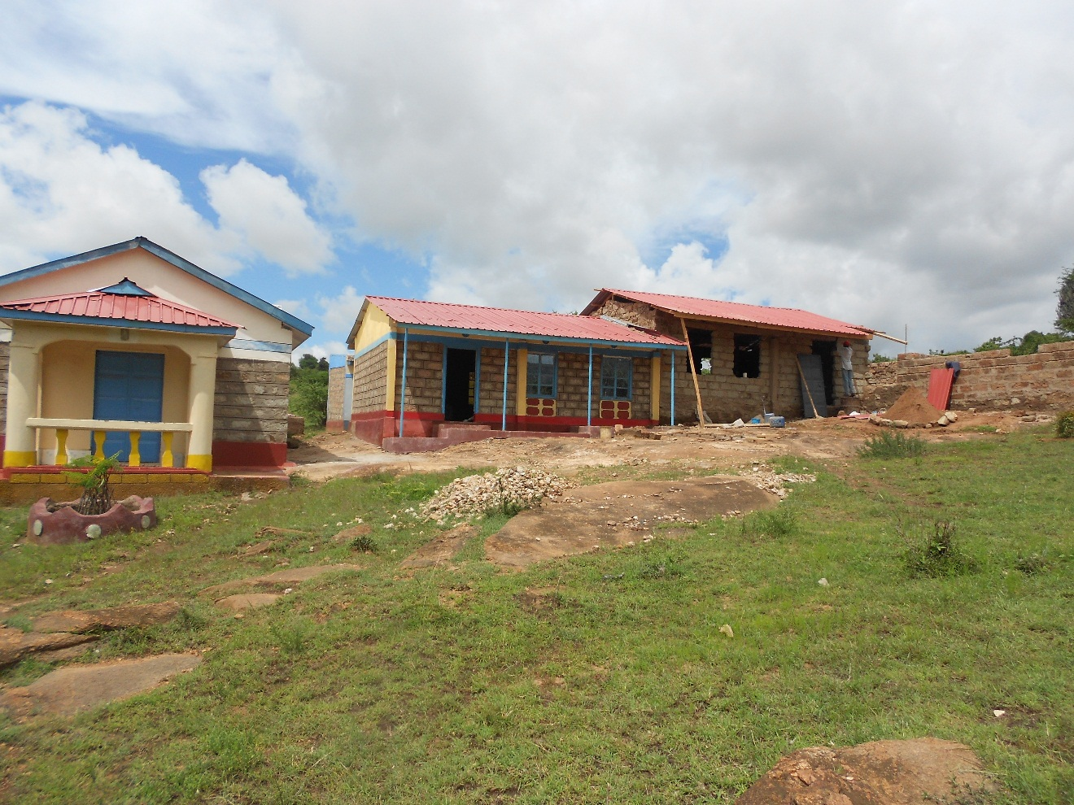

**The finishing of the second class.**

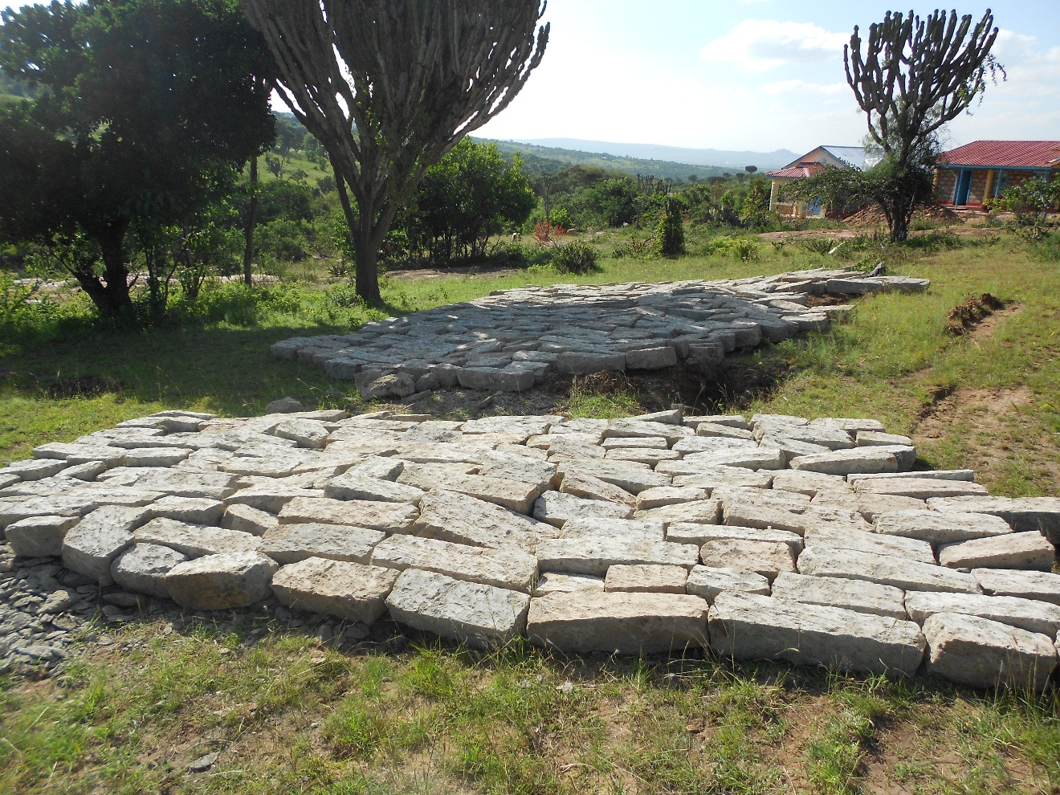

**More blocks**

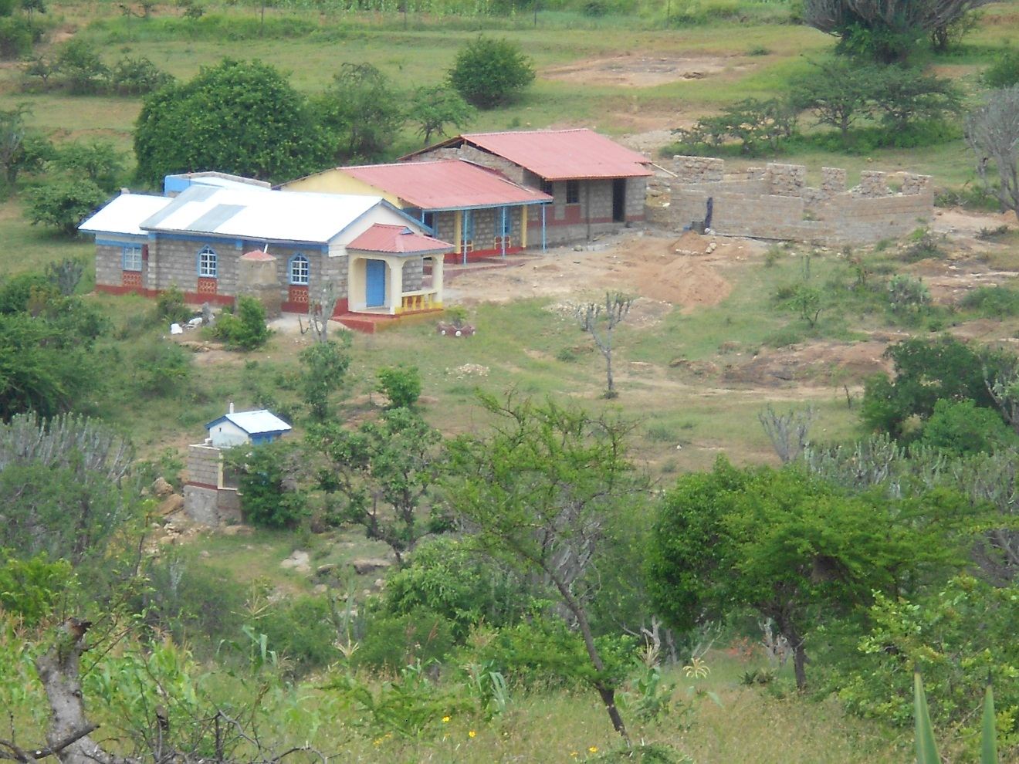

**The extension to four classes.**

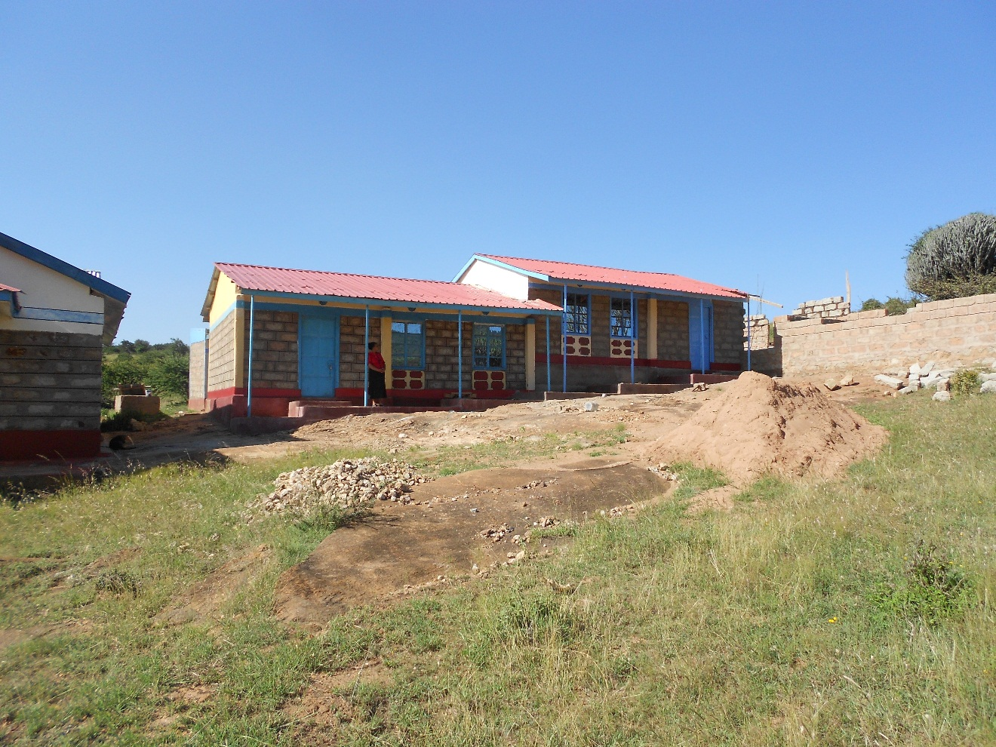

**Making the front of the second class more welcoming**

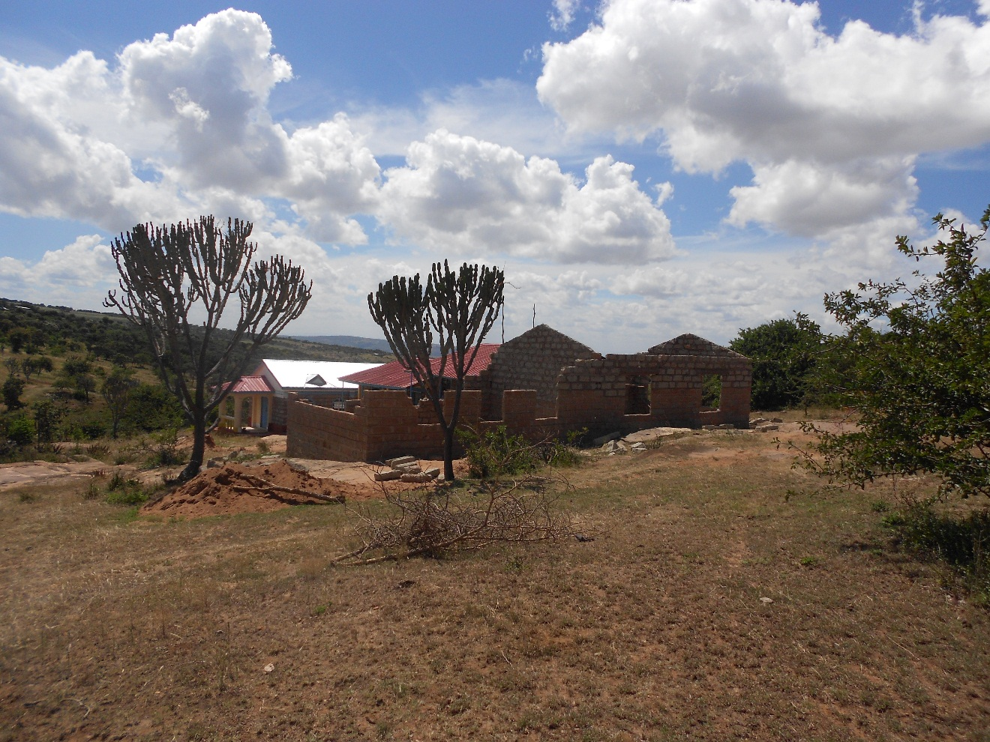

**The other classes are taking the high looks as at 27th Feb 2016**

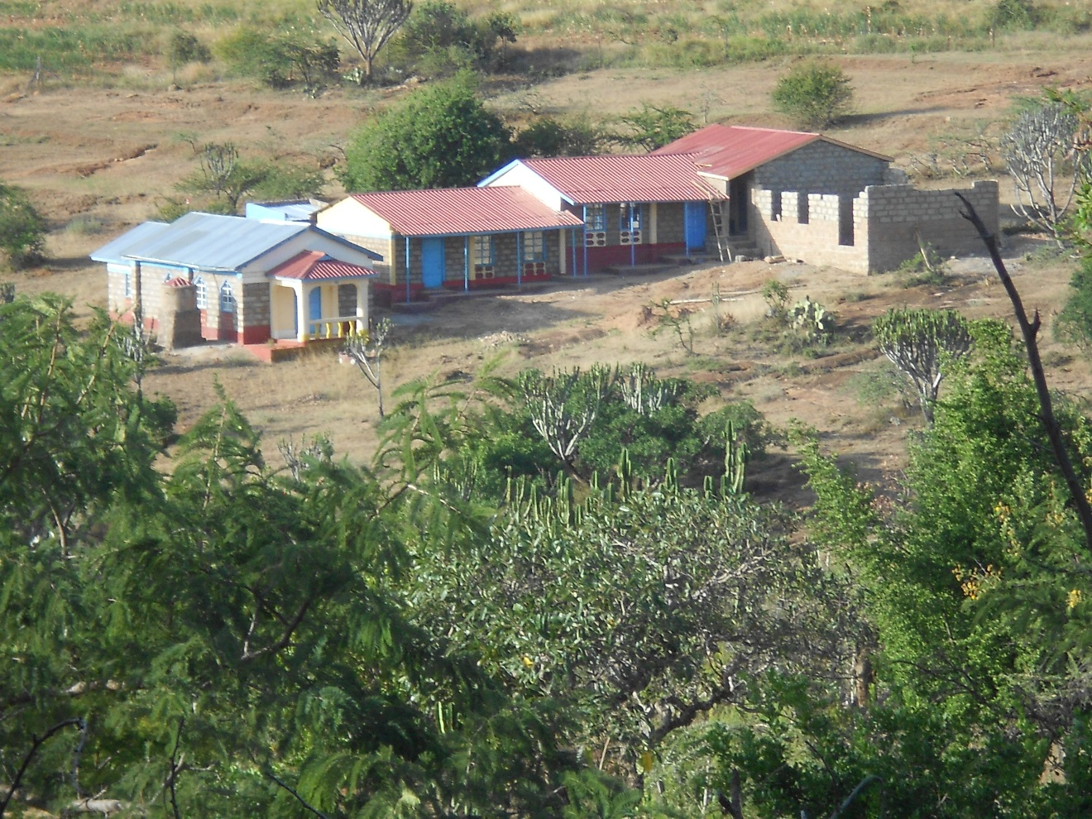

**The third class is roofed and doors fixed.**

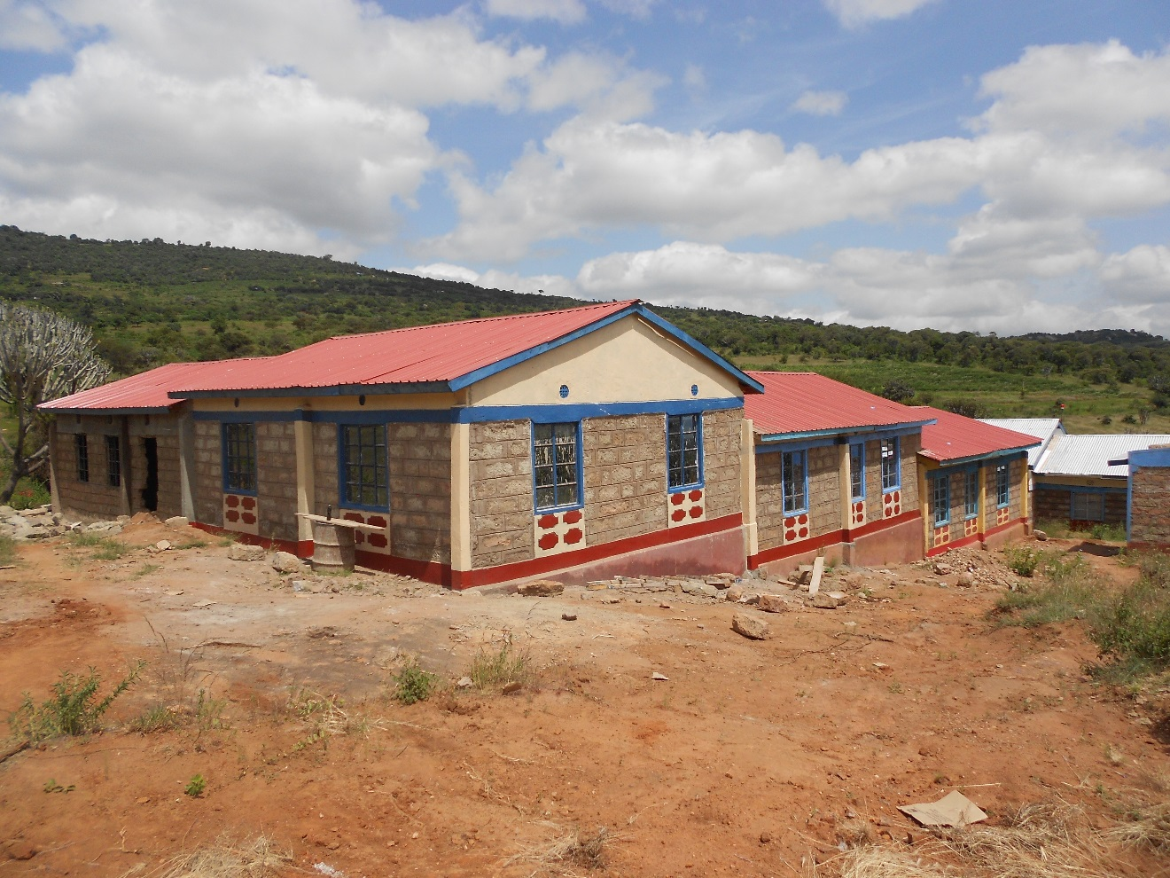

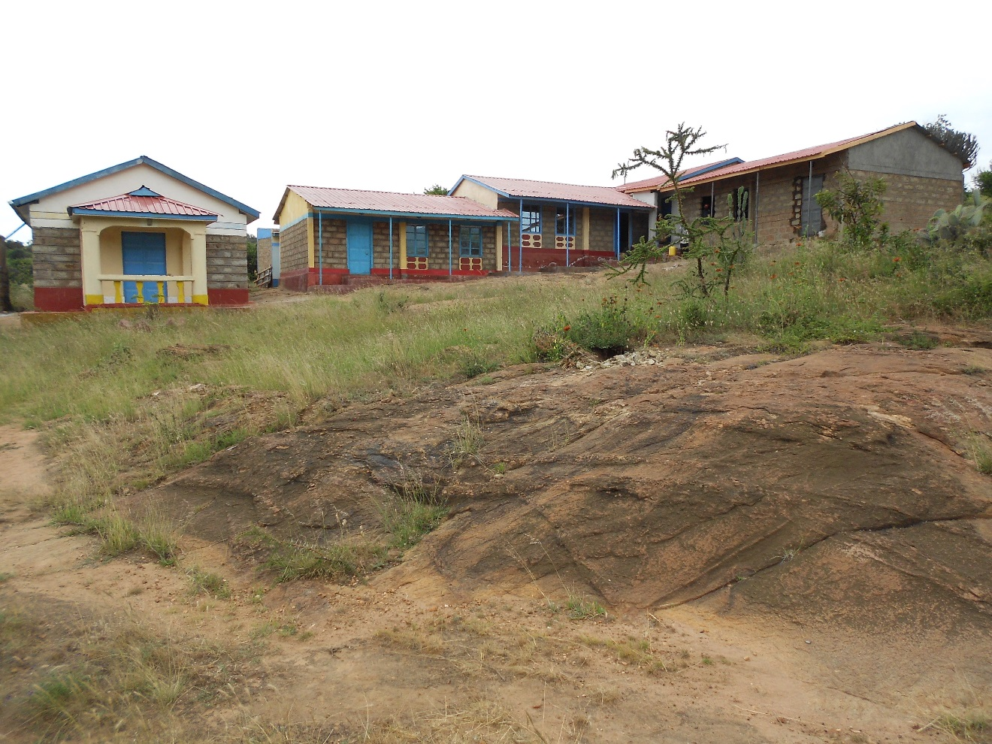

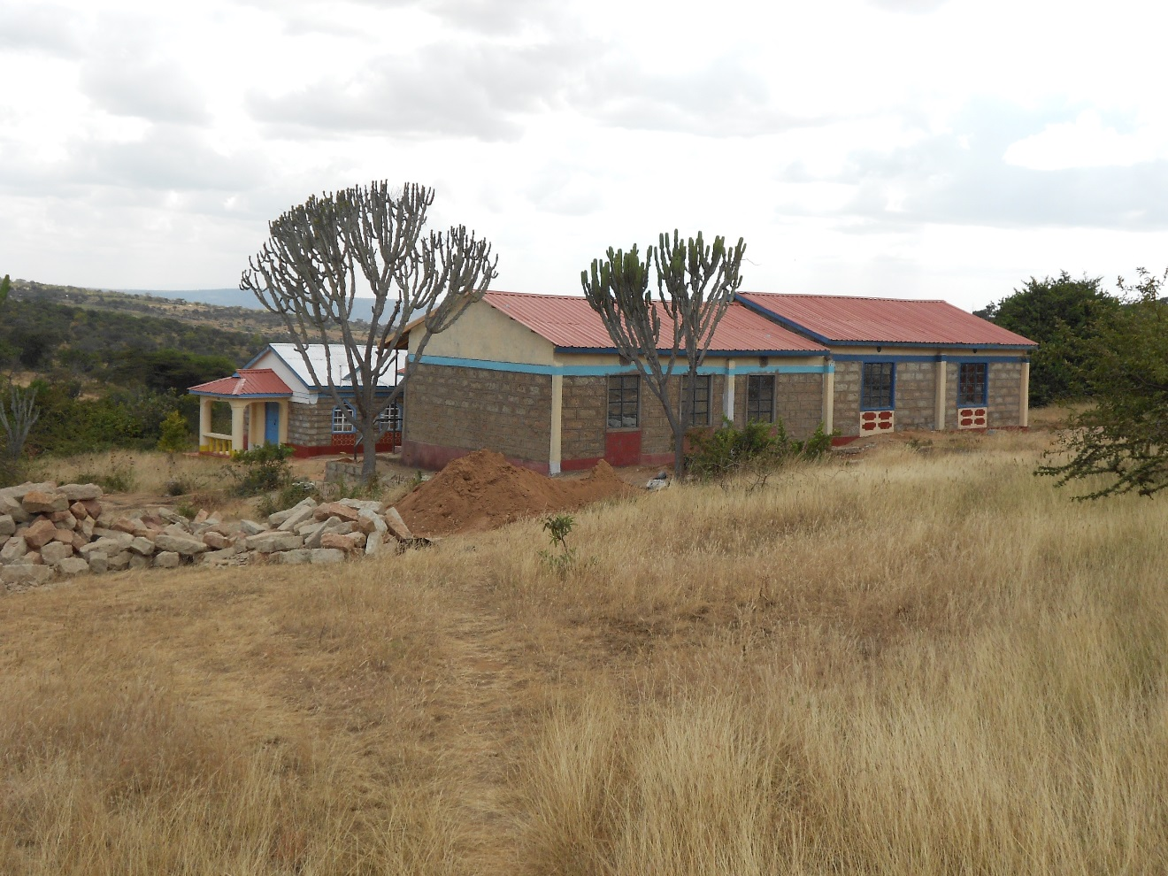

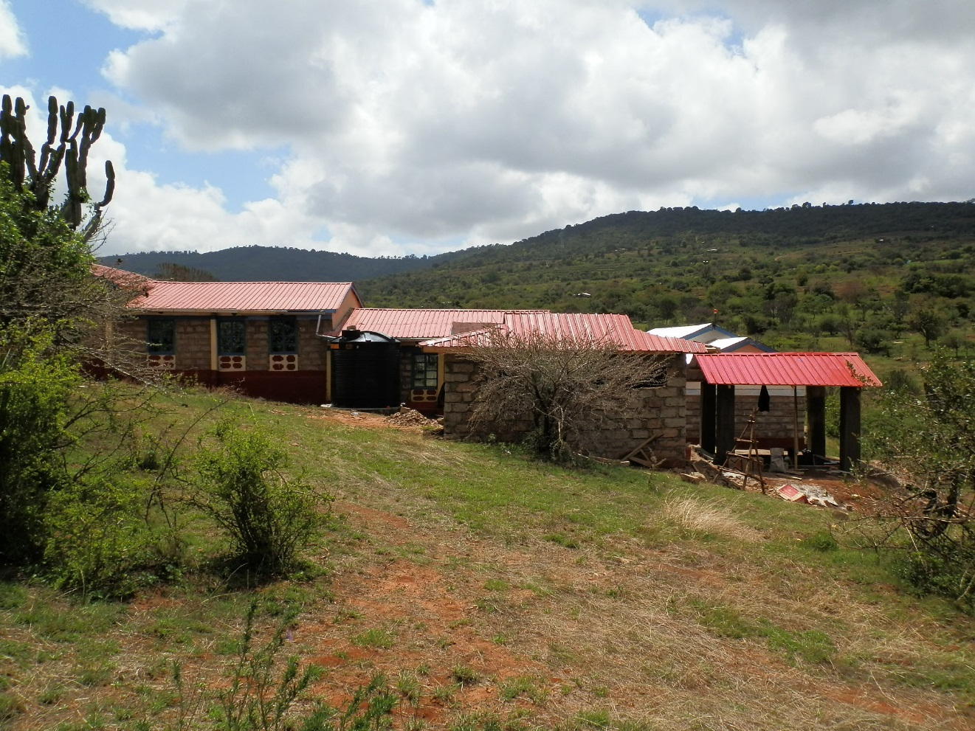

**The construction of a baptismal pool, bath room and the water tank (10000 litres).**

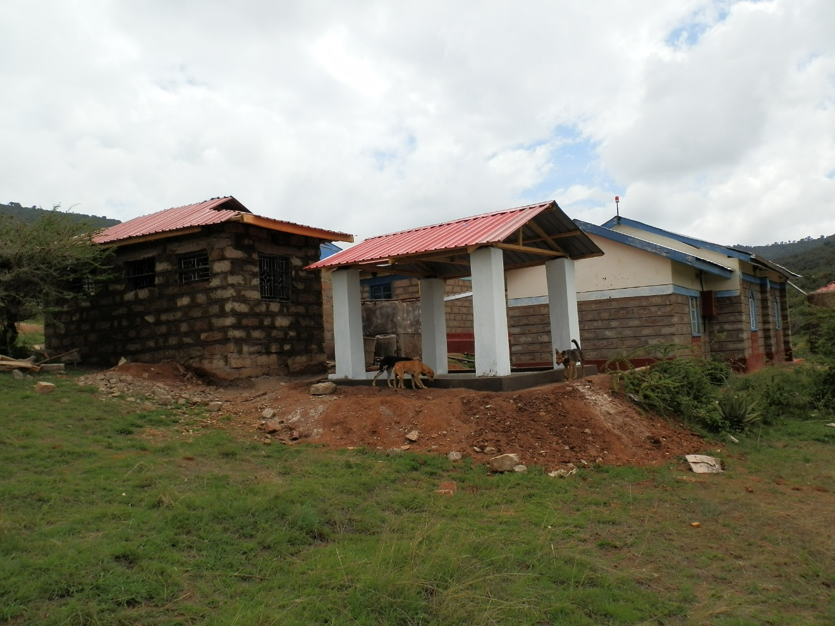

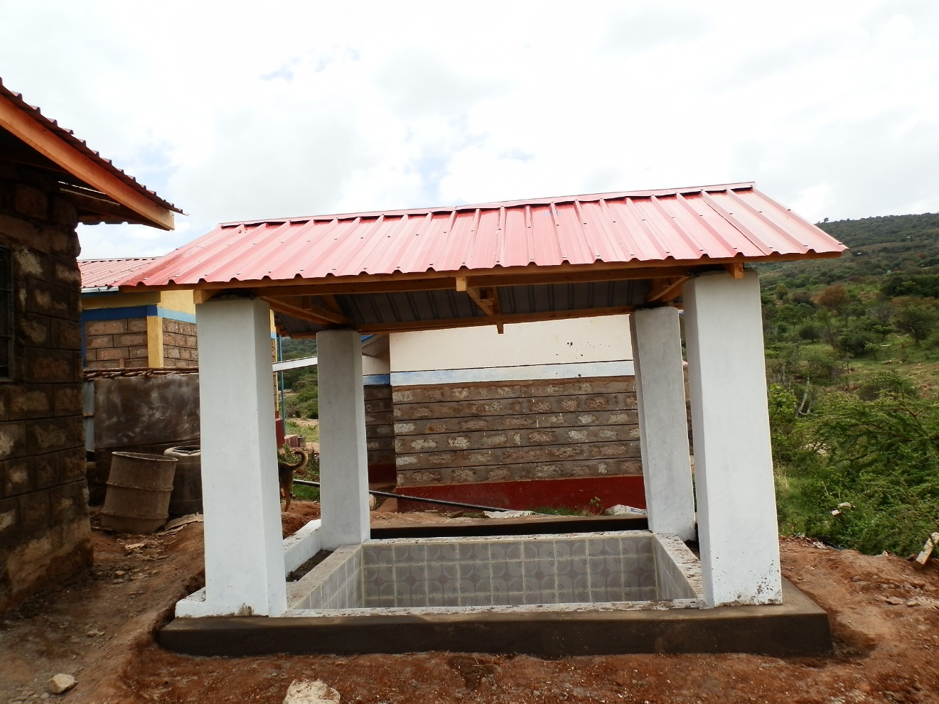**Improved baptismal pool**

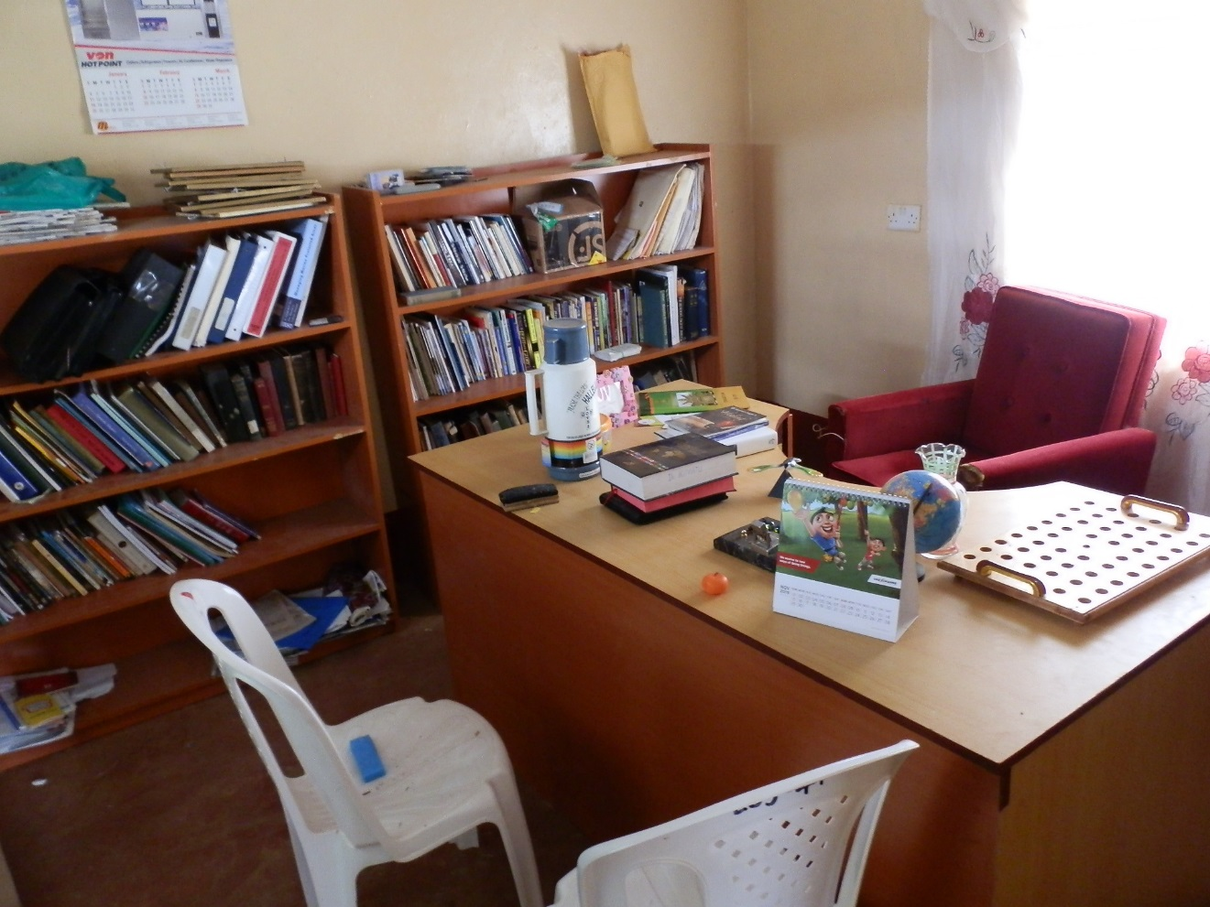

**Equipping of the Bible school library**

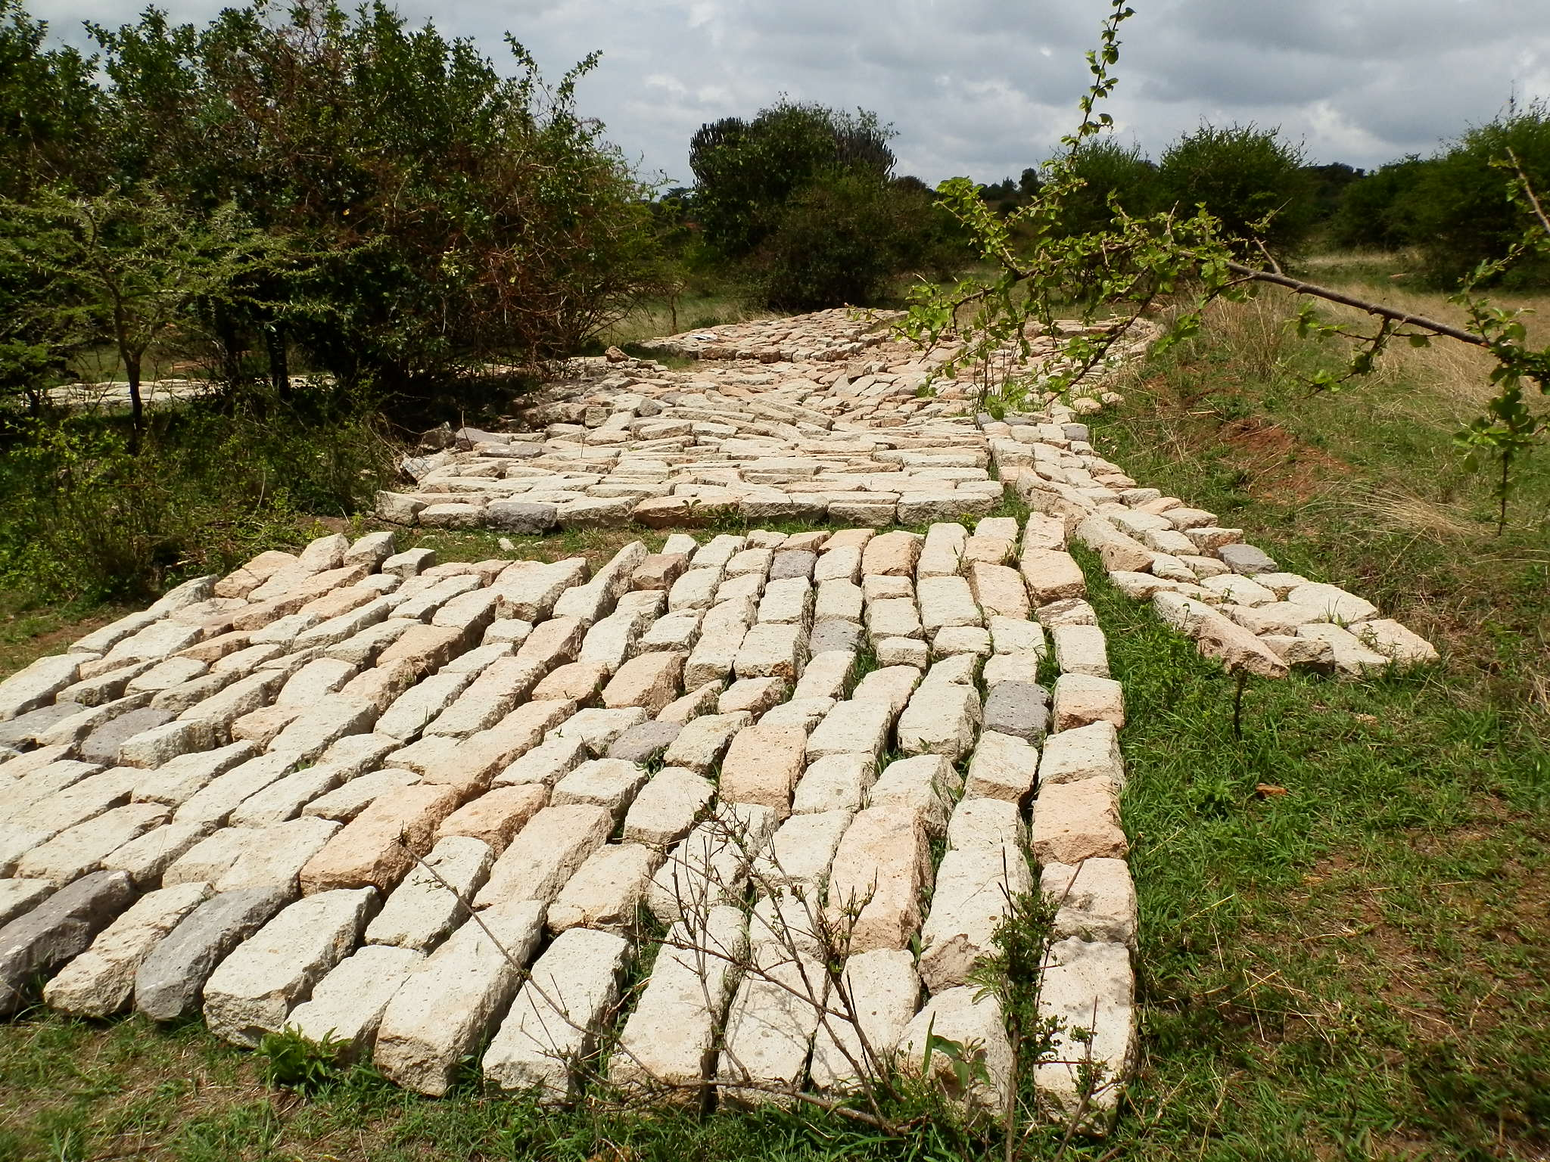

**Blocks to construct a supplementary secondary school**

**You can send kind donations to:**

**This is the details of my bank account:**

**Account Name: Josphert N Kimatu,**

**Bank Name: Barclays Bank,**

**Branch: Machakos**

**Country: Kenya.**

**Swift Code: BARCKENX**

**Bank code: 03**

**Branch code : 040**

**Account number : 0403570923**

**God bless you so much as you plan to support His work.**

**Amen**